**‘AccessBank DBA Internship Program’**

**Project 14: Shrinking Files**

You got access to the new server. While investigation, you find out that one of the databases has a large size and it is rarely used. Log file is OK, but Data file is oversized. Its size is 350 MB and just 10 MB is used. Based on your calculations, it increases by 10 MB throughout the year. You have a lot of space left unused.

Shrinking is not a good practice. It is not recommended to perform it as it causes index fragmentation and consumes a lot of resources while running. However, because you have less space in your disk storage and change of data distribution is slow, you can perform shrinking of data file

To simulate this scenario, do the following tasks:

1. Remove AdventureWorks2014 database from your server and restore new modified version:

<https://drive.google.com/file/d/1m-r4AoM97QumJW4L4sb5LXz7WPb5IF6K/view?usp=sharing>

**I deleted AdventureWorks2014 database and downloaded modified version of its full backup and by using that backup file I restored the database successfully**: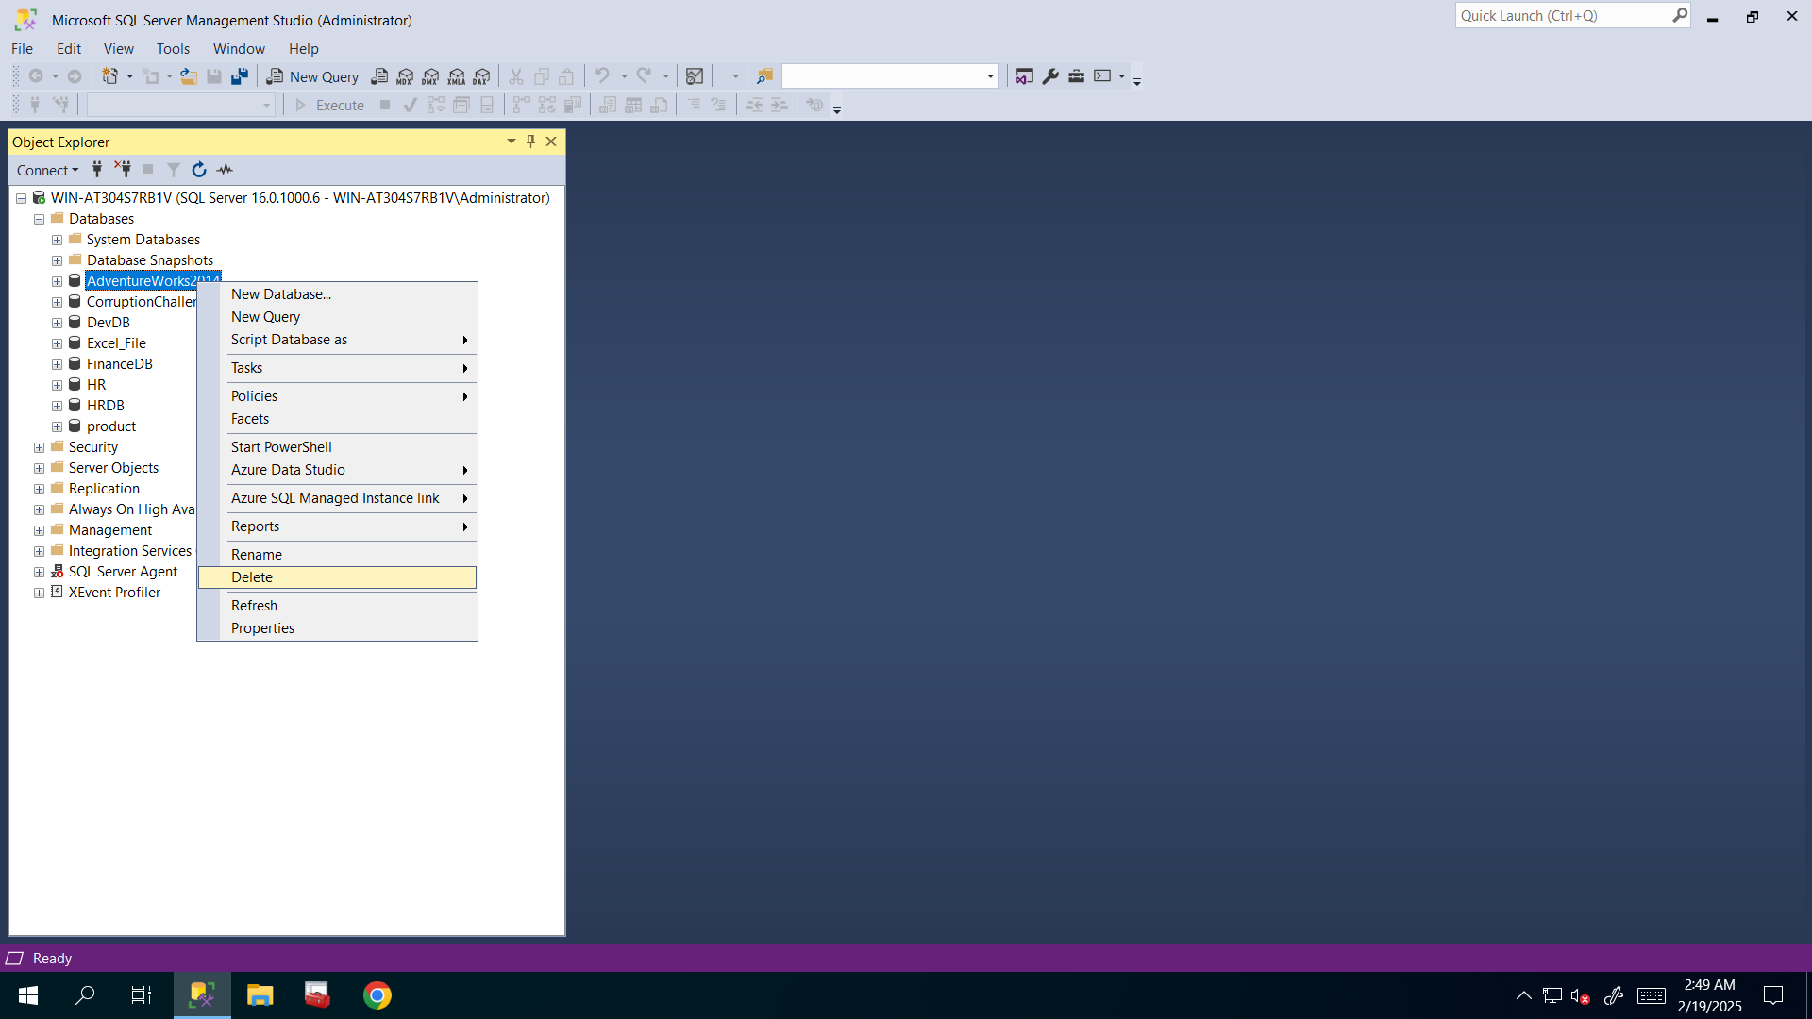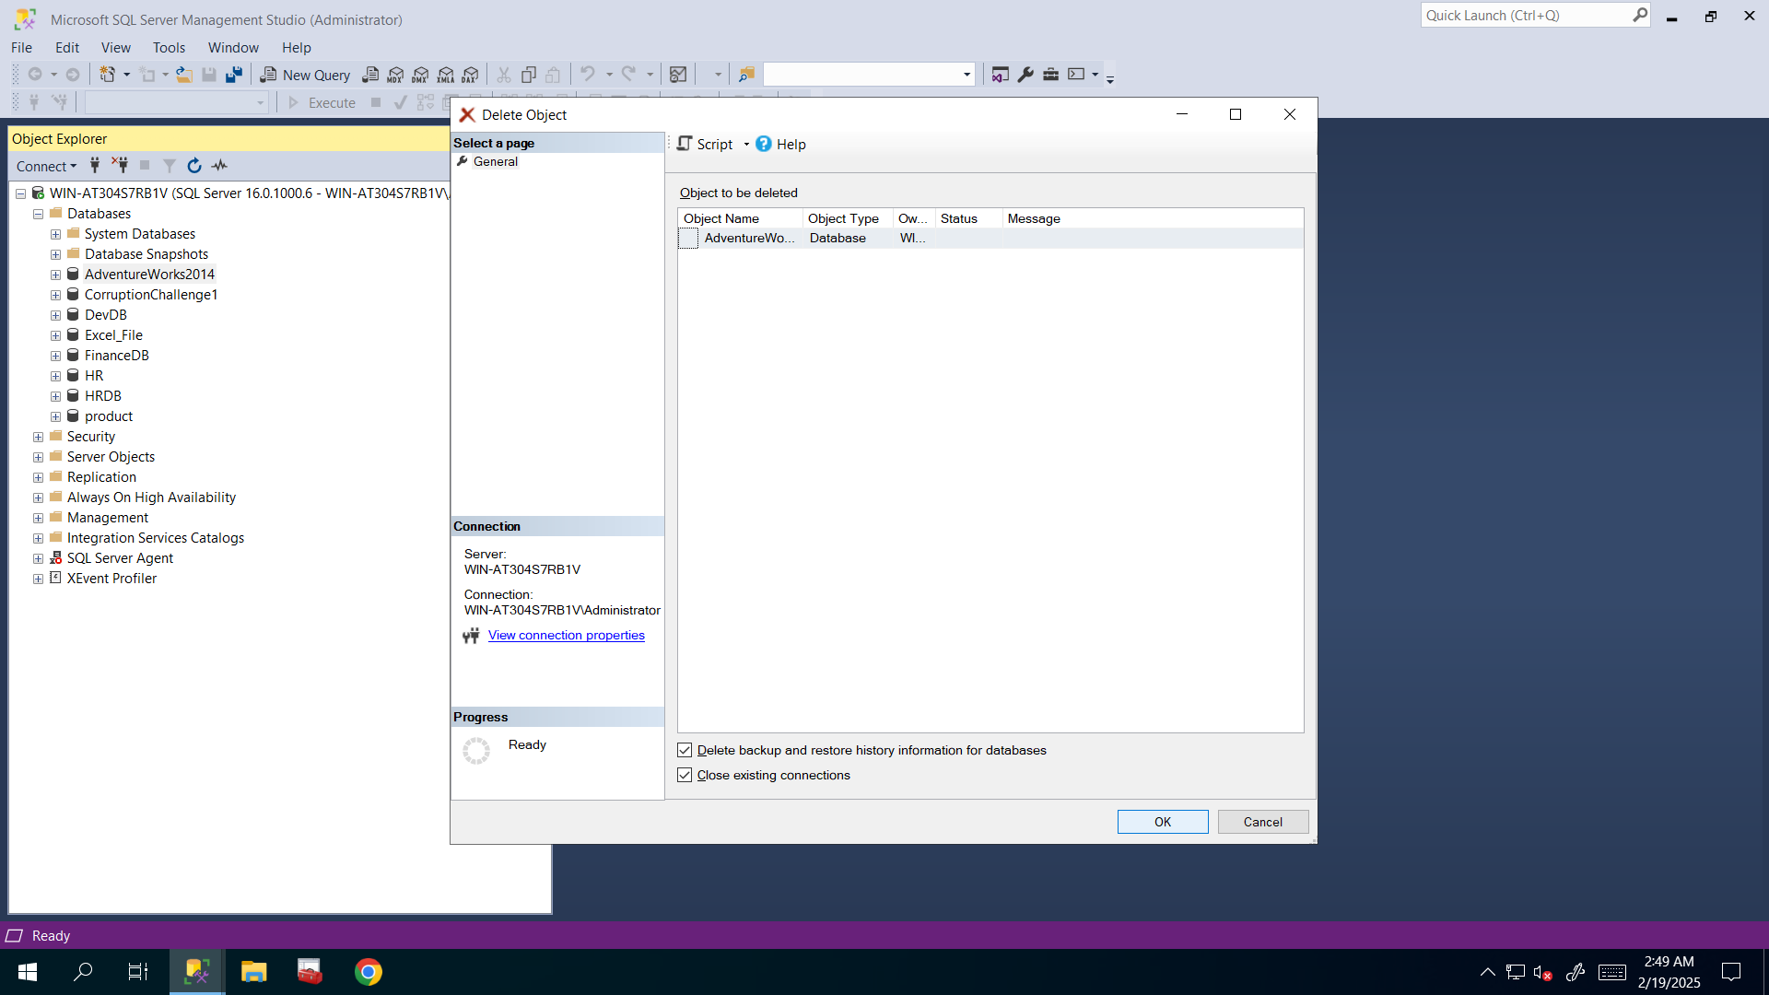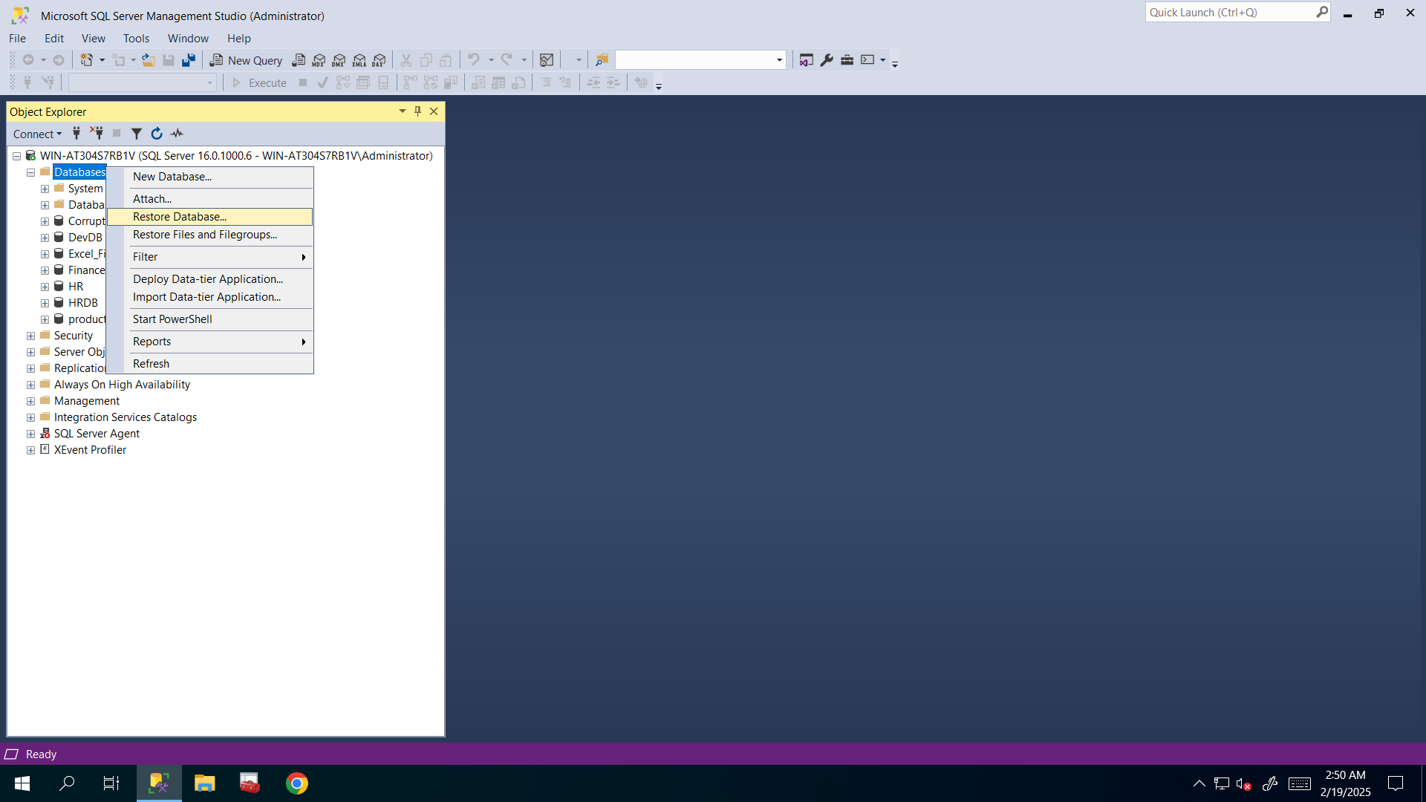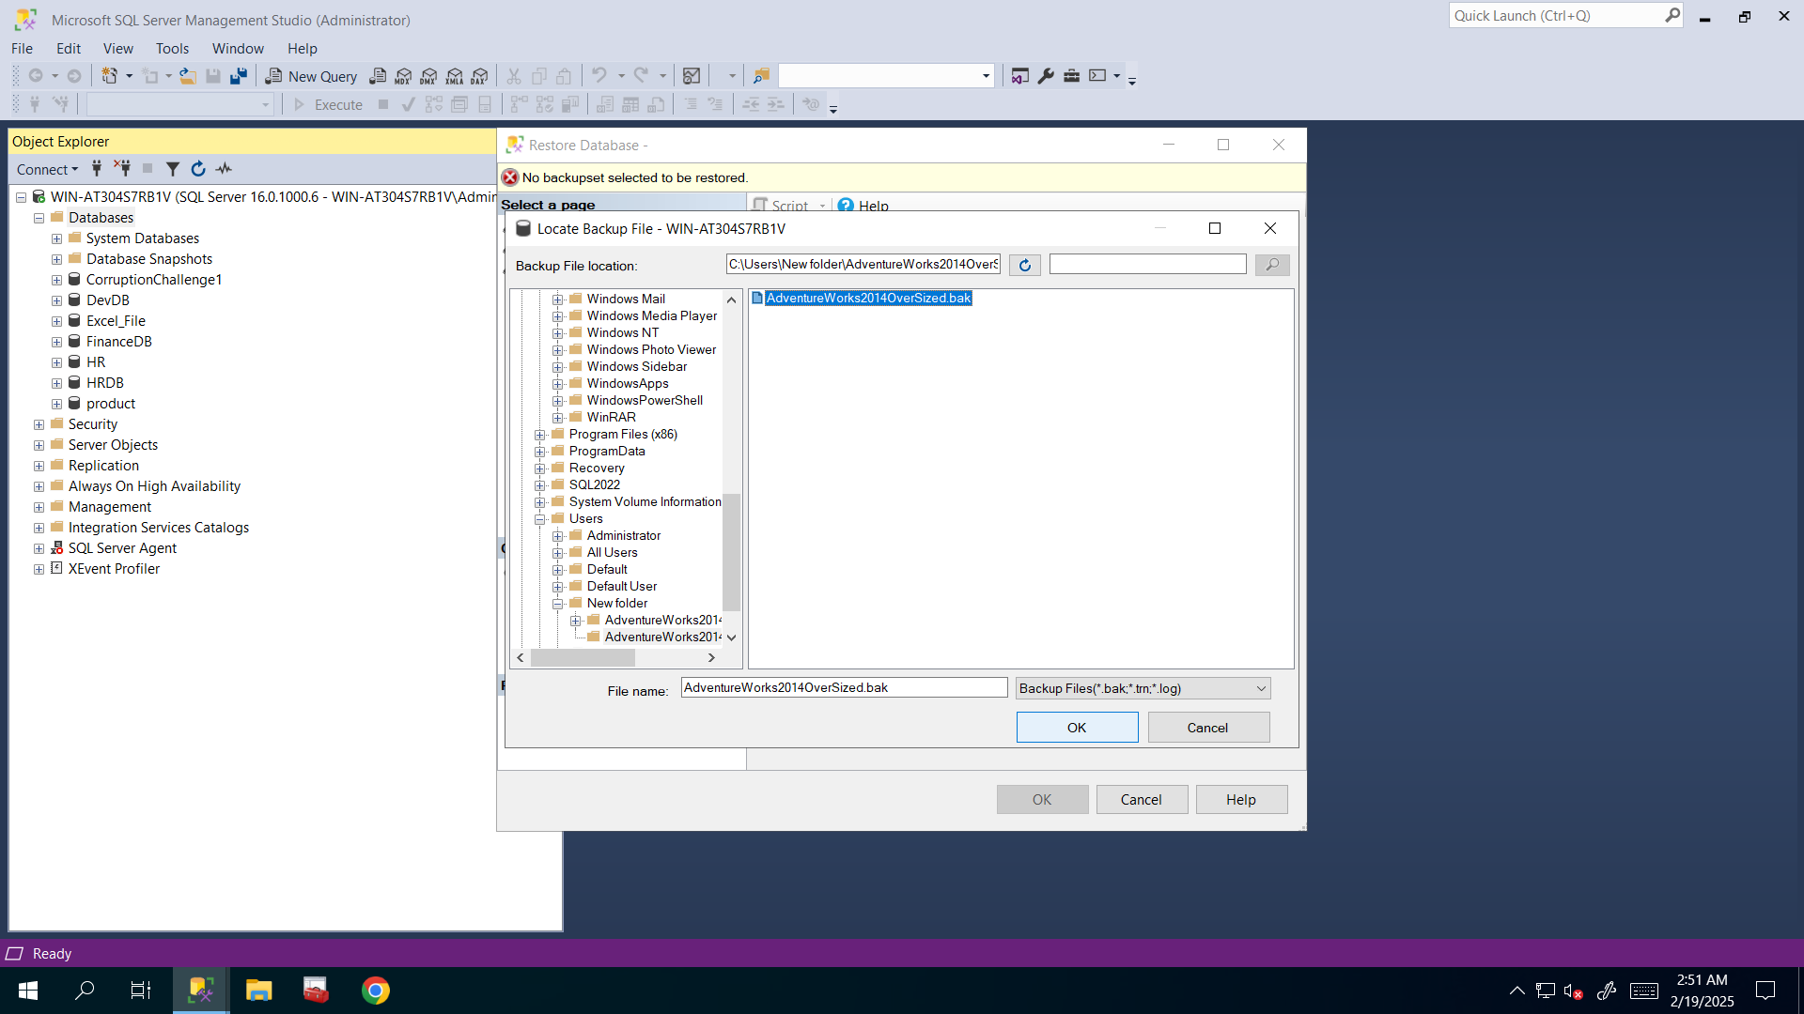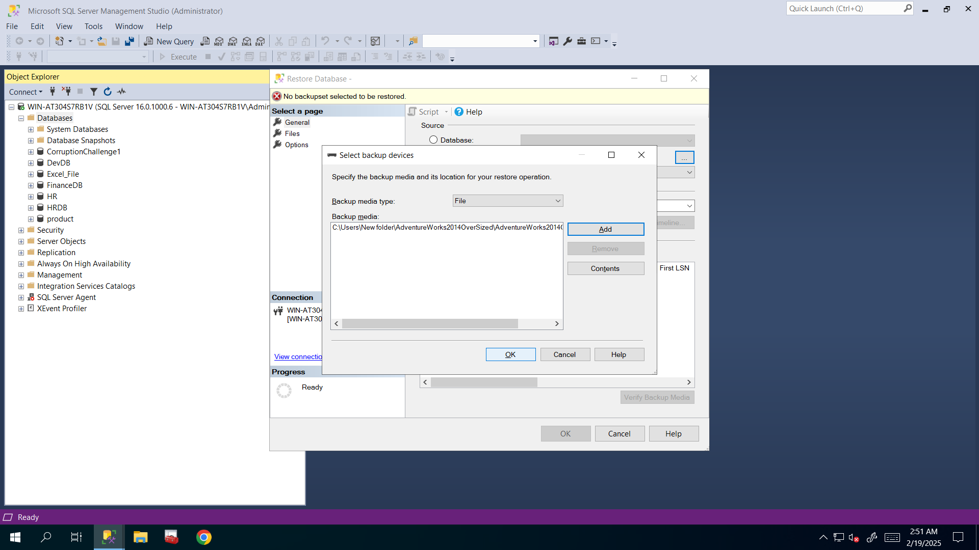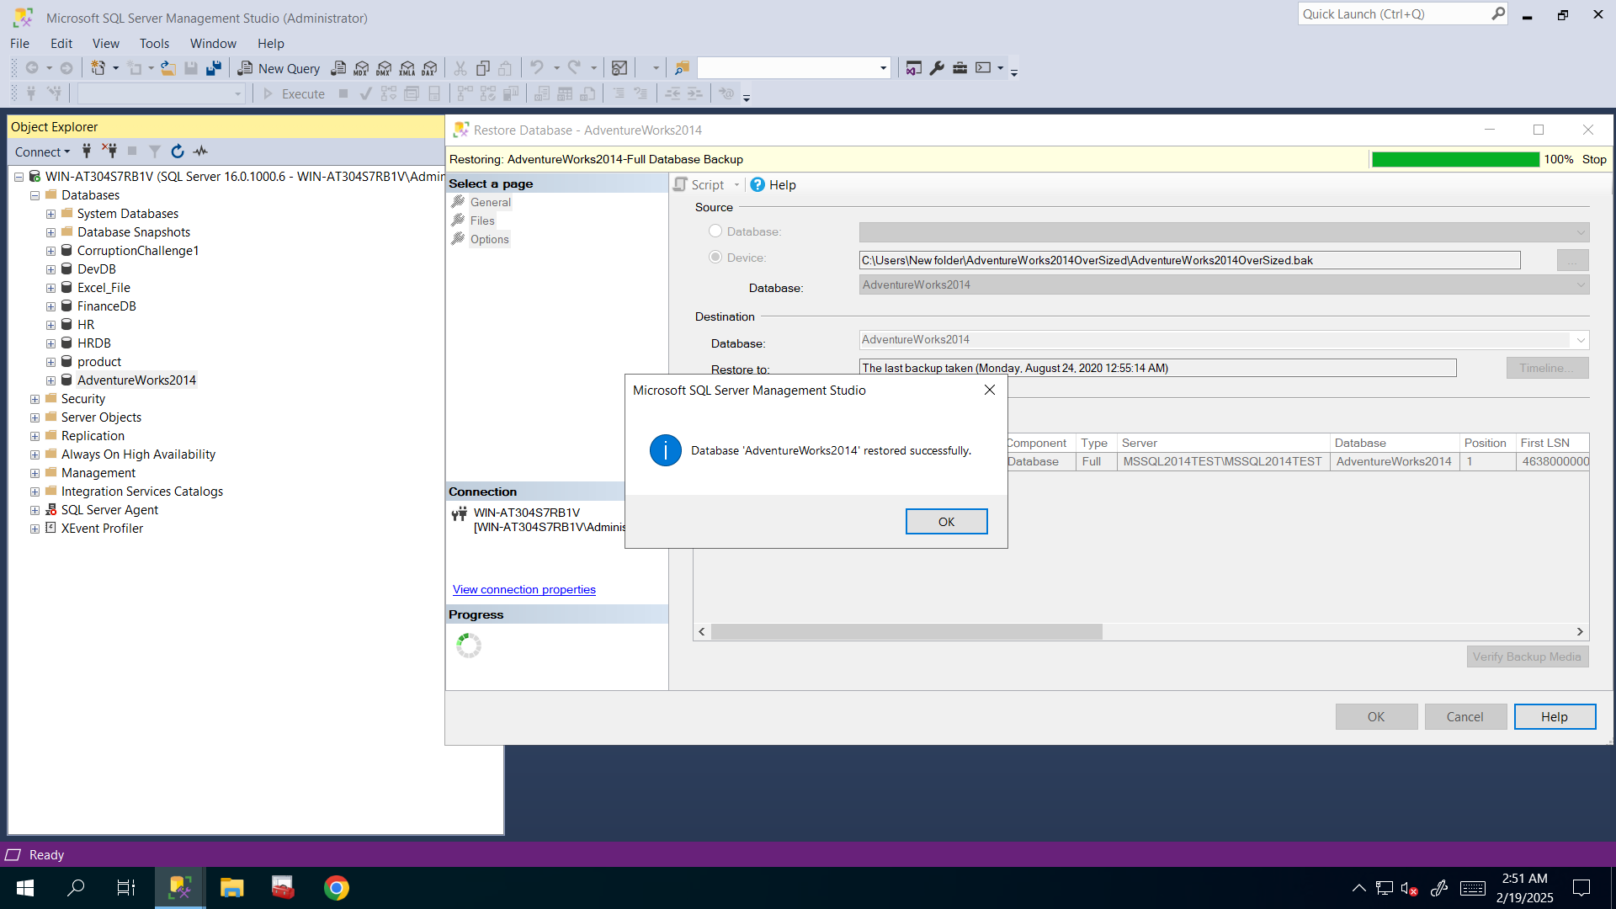

1. Check the sizes of data file before shrinking it using the following query:

USE AdventureWorks2014

GO

SELECT DB_NAME() AS DbName,

name AS FileName,

type_desc,

size/128.0 AS CurrentSizeMB,

size/128.0 - CAST(FILEPROPERTY(name, 'SpaceUsed') AS INT)/128.0 AS FreeSpaceMB

FROM sys.database_files

WHERE type IN (0,1)

GO

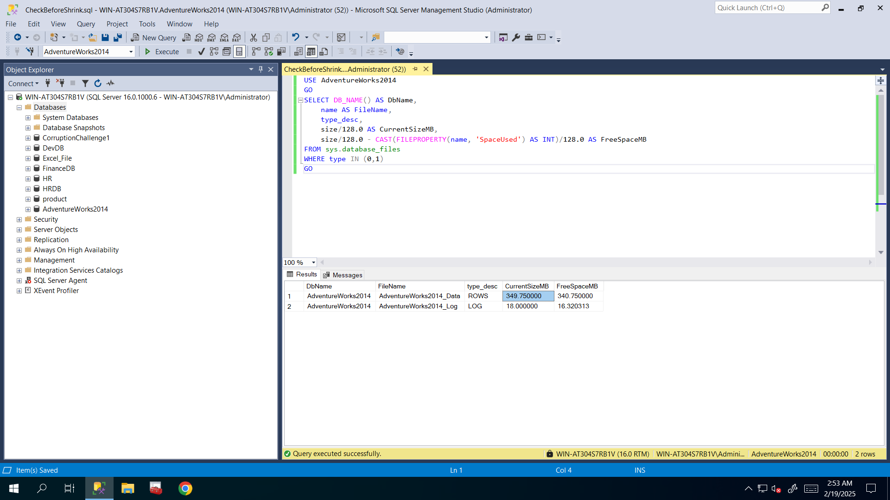

**I executed above query before shrinking as you said and saw that 349mb is its size and 340mb of it is free so data is about 9mb so I will shrink that file to 20mb because I need to give it some free space too.**

1. Perform data file shrinking

Hint: if you want to get logical name of data file, then use the following system stored procedure:

USE AdventureWorks2014

GO

EXEC SP_HELPFILE

**Okay so I executed above query to get logical name of that database’s data file and copied it to use in next query**: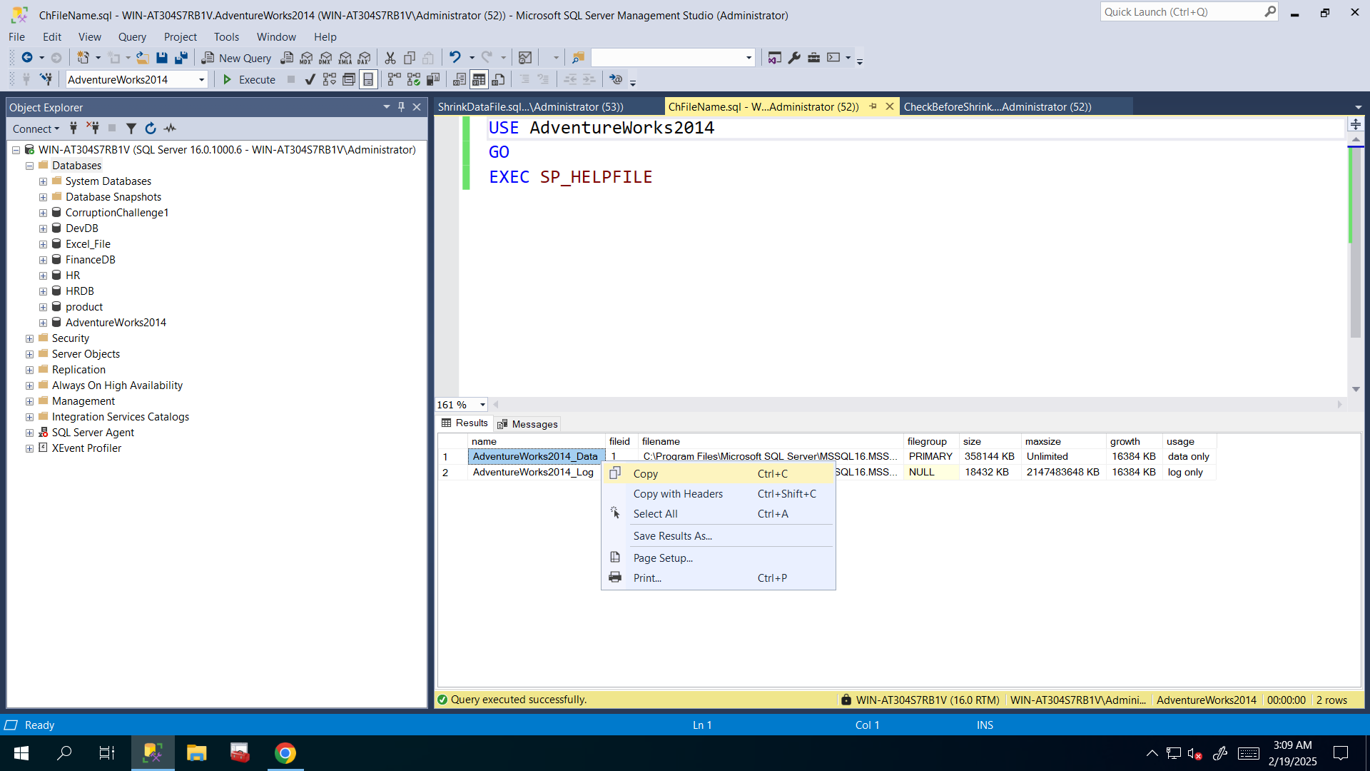

**And I shrinked the database’s data file by using following query to 20mb**:

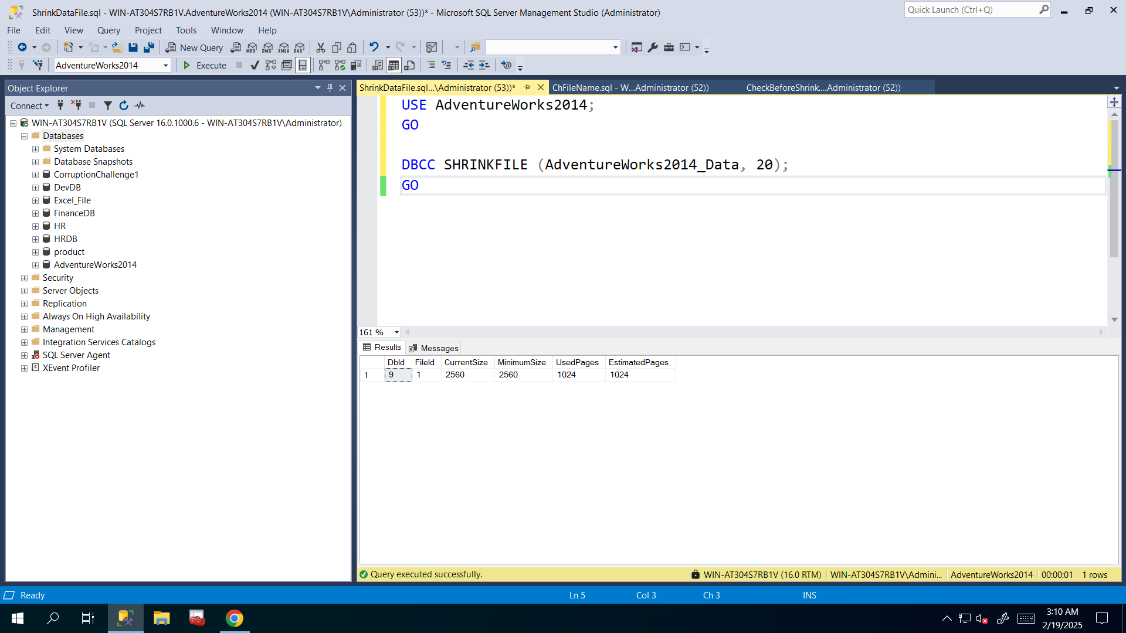

1. Check the sizes of data file after shrinking it using the following query:

USE AdventureWorks2014

GO

SELECT DB_NAME() AS DbName,

name AS FileName,

type_desc,

size/128.0 AS CurrentSizeMB,

size/128.0 - CAST(FILEPROPERTY(name, 'SpaceUsed') AS INT)/128.0 AS FreeSpaceMB

FROM sys.database_files

WHERE type IN (0,1)

GO

**And after shrinking now it is 20mb and there is 11mb free space left:**

